Profile of the

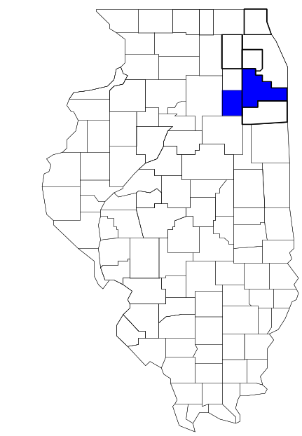Joliet Metropolitan Area Narcotics Squad

Prepared by

The Research and Analysis Unit of the
Illinois Criminal Justice Information Authority

George H. Ryan, Governor
Peter B. Bensinger, Chairman
Candice M. Kane, Executive Director

March 2001



ILLINOIS
CRIMINAL JUSTICE
INFORMATION AUTHORITY

This project was supported by Grant # 99-DB-BX-0017, awarded to the Illinois Criminal Justice Information Authority by the Bureau of Justice Assistance, Office of Justice Programs, U.S. Department of Justice. The Assistant Attorney General, Office of Justice Programs, coordinates the activities of the following programs, offices and bureaus: Bureau of Justice Assistance, Bureau of Justice Statistics, National Institute of Justice, Office of Juvenile Justice and Delinquency Prevention, and the Office for Victims of Crime. Points of view or opinions contained within this document are those of the authors and do not necessarily represent the official position or policies of the U.S. Department of Justice.

Illinois Criminal Justice Information Authority
120 S. Riverside Plaza, Suite 1016
Chicago, Illinois 60606-3997
Telephone (312) 793-8550
Telefax (312) 793-8422
TDD: (312) 793-4170
World Wide Website http://www.icjia.state.il.us
ACKNOWLEDGMENTS

A number of organizations and individuals put a great deal of effort into the development of this document. The Authority’s Research and Analysis Unit is very grateful for the assistance provided by the following organizations:

Administrative Office of the Illinois Courts
Illinois Department of Human Services’ Office of Alcoholism and Substance Abuse
Illinois Department of Children and Family Services
Illinois Department of Corrections
Illinois State Police
Joliet Metropolitan Area Narcotics Squad
U.S. Bureau of the Census

In addition, the following individuals were instrumental in gathering, interpreting and presenting these data:

Sharyn Adams

Megan Alderden

Robert Bauer

Alissa Clark

John Condne

Karen Griffiths

Tracy Hahn

Jennifer Hiselman

David Katz

Joseph Kozenczak

Gary Kupsak

Erica Morrow

David Olson

Adrianna Perez

Gerard Ramker

Robert Taylor

CONTENTS

Section Page Number

EXECUTIVE SUMMARY

I. Introduction 1
II. Trends in Violent Index Offenses and Arrests 3
III. Trends in Drug Arrests 6
IV. Trends in Drug Seizures 14
V. Trends in Prosecutions for Drug Offenses 16
VI. Trends in Percent of Convicted Drug Offenders Sentenced to Prison 18
VII. Trends in Drug Treatment Admissions in MANS Region by Drug Type 23
VIII. Trends in Drug Exposed Births 26
IX. Summary of Drug Situation 27
X. Appendices 29
Map 1 1999 Percent of Illinois' County-level Population Covered by an
Authority-funded Multi-jurisdictional Enforcement Group or Task Force 30
Map 2 1999 Illinois Cannabis Seizure Rates, by County 31
Map 3 1999 Illinois Controlled Substances Seizure Rates, by County 32
Map 4 1999 Illinois Methamphetamine Seizure Rates, by County 33
XI. Bibliography 34

LIST OF FIGURES

Figure Page Number

Figure 1. Violent Index Offense Rates for Participating and Non-participating Agencies in Region Covered by MANS 3
Figure 2. 1999 Violent Index Offenses* Reported by Participating and Non-participating Agencies in Region Covered by MANS 4
Figure 3. Violent Index Arrest Rates for Participating and Non-participating Agencies in Region Covered by MANS 5
Figure 4. 1999 Violent Index Arrests* Reported by Participating and Non-participating Agencies in Region Covered by MANS 5
Figure 5. Total Drug Arrest Rates for MANS and Participating and Non-participating Agencies in Region Covered by MANS 7
Figure 6. 1999 Drug Arrests* Reported by Participating and Non-participating Agencies in Region Covered by MANS 7
Figure 7. Total 1999 Drug Arrests* Reported by Participating and Non-participating Agencies in Region Covered by MANS, by Drug Type 8
Figure 8. Drug Arrests by MANS 9
Figure 9. Percent of Total Drug Arrests Accounted for by MANS 9
Figure 10. Cannabis Arrests Rates in the Region Covered by MANS as Reported by Participating Agencies, Non-participating Agencies and MANS 10
Figure 11. Percent of Cannabis Arrests Accounted for by MANS
11
Figure 12. Controlled Substances Arrest Rates in the Region Covered by MANS as Reported by Participating Agencies, Non-participating Agencies and MANS 12
Figure 13. Percent of Controlled Substances Arrests Accounted for by MANS 12
Figure 14. MANS Drug Arrests for Possession versus Delivery, by Drug Type 13
Figure 15. Cannabis Seized and Submitted to ISP by Grundy and Will Counties and Seized by MANS 14
Figure 16. Powder and Crack Cocaine Seized and Submitted to ISP Grundy and Will and Seized by MANS 15
Figure 17. Number of Felony Filings in Grundy and Will Counties 16
Figure 18. Total MANS Drug Arrests and Percentage of Arrests Resulting in Prosecution 17
Figure 19. Sentences Imposed on Felons Convicted in Grundy and Will Counties
18
Figure 20. Sentences Imposed on Convicted MANS Drug Offenders 19
Figure 21. Number of Drug Offenders Committed to IDOC by MANS and Region Covered by MANS 20
Figure 22. Drug Offenders as a Percent of Total IDOC Commitments from Grundy and Will Counties 21
Figure 23. Drug Offenders Committed to IDOC Grundy and Will Counties, by Offense Class 22
Figure 24. Substance Abuse Treatment Admissions from Grundy and Will Counties 23
Figure 25. Comparison of Drug Arrests by MANS and Participating and Non-participating Agencies vs. Drug Abuse Treatment Admissions Grundy and Will Counties, 1999 25
Figure 26. Cases of Drug-Exposed Infants in Grundy and Will Counties 26
Figure 27. Availability of Drugs in Illinois, 1998 27
Figure 28. Price Per Gram in Illinois, 1998 28

EXECUTIVE SUMMARY

Since 1989, the Authority’s Research and Analysis Unit has received funds under the federal Anti-Drug Abuse Act of 1988 to document the extent and nature of drug and violent crime in Illinois and the criminal justice system’s response to these offenses. As a result of these efforts, the Authority has amassed a large amount of data measuring the extent and nature of drug and violent crime in Illinois and the impact these crimes have had on the criminal justice system. In addition, as part of its monitoring and evaluation efforts, the Authority also requires funded programs to submit monthly data reports describing their activities and accomplishments. This profile is intended to provide a general overview of the drug and violent crime problem in the jurisdictions covered by Illinois’ MEGs and task forces, and the response to these problems by the units.

Although the data presented in this report are by no means inclusive of all indicators, they do provide a general overview of drug and violent crime and the response and impact of the criminal justice system. The following represent general conclusions that can be made based on the data analyzed for this report.

- In 1999, 12 local Illinois police agencies participated in MANS (a participating agency is defined as one that contributes either personnel or financial resources to MANS). Officers assigned to MANS (totaling 13 in 1999, 11 from participating agencies) accounted for one percent of the total number of sworn police officers working for agencies participating in MANS.

- The violent Index offense rate was higher across the jurisdictions that did not participate in MANS than it was among the combined jurisdictions that did participate in MANS, until 1997, when the violent Index offense rate for participating agencies was slightly higher than non-participating agencies (page 3).

- The drug arrest rate tended to be higher in the jurisdictions that did not participate in MANS than in those jurisdictions that participated in MANS. The drug arrest rate achieved by MANS, however, was significantly lower than that achieved by both the participating and non-participating agencies (page 6).

- When comparing the types of drug offenders arrested by those agencies participating in MANS, those agencies not participating, and MANS, it was found that MANS tended to target and arrest more serious drug law violators, specifically violators of the Controlled Substances Act, which tend to be felony-level offenses (page 8).

- The majority of all drug arrests reported by MANS, for either violations of the Cannabis Control Act or the Controlled Substances Act, involve drug sale or delivery (page 13).

- Between 1993 and 1999, the amount of cannabis and cocaine seized by MANS increased dramatically (pages 14 and 15).

- Between 1991 and 1999, 85 percent of all drug arrests by MANS resulted in prosecution. Of these MANS drug offender prosecutions, three-quarters were for violations of Controlled Substances Act. In addition, between 1989 and 1999, 86 percent of all drug offenders who were prosecuted as a result of MANS activity were convicted (page 17).

- In 1999, among those MANS drug offenders convicted and sentenced, probation sentences accounted for the largest proportion (48 percent), followed by prison sentences (41 percent) and jail sentences (11 percent) (page 19).

- Between 1989 and 1999, prison sentences resulting from MANS cases accounted for only 35 percent of all drug-law violators sent to prison from the region where MANS operates (page 20).

- Unlike the arrests made by the participating and non-participating agencies, the arrests made by MANS tended to involve the substances considered to be most serious (i.e., felony versus misdemeanor) and the substances for which a large proportion of community residents were seeking and receiving substance abuse treatment in 1999 (page 24).

I. Introduction

The Joliet Metropolitan Area Narcotics Squad (MANS) covers the Illinois counties of Grundy and Will. Combined, these counties had a 1999 total population of 486,798 – 24 percent more than in 1990. In 1999, twelve local Illinois police agencies participated in MANS. These include the Grundy County Sheriff's Office, the Will County Sheriff’s Office and the following municipal police departments: Bolingbrook, Joliet, Lockport, Coal City, Frankfort, Mokena, Morris, New Lenox, Rockdale, Romeoville. These agencies served nearly 82 percent of the population in the two-county region covered by MANS in 1999 (see Map 1 on page 30). A participating agency is defined as one that contributes either manpower or financial resources to MANS.

In addition to agencies that participate in MANS, these Illinois counties are served by 21 additional police departments that do not participate in MANS. According to the Illinois State Police, county sheriffs and local police departments, in the two-county region covered by MANS, combined, employed 969 full-time police officers as of Oct. 31, 1999. In comparison, there were a total of just 13 officers assigned to MANS in 1999, 11 of which were assigned by participating agencies and two from the Illinois State Police. Thus, the officers assigned to MANS during 1999 accounted for a relatively small proportion – 1 percent – of the total number of sworn police officers working in the participating police departments, and the region as a whole.

Since 1989, the Authority’s Research and Analysis Unit has received funds under the federal Anti-Drug Abuse Act of 1988 to document the extent and nature of drug and violent crime in Illinois and the criminal justice system’s response to these offenses. As a result of these efforts, the Authority has amassed a large amount of data measuring the extent and nature of drug and violent crime in Illinois and the impact these crimes have had on the criminal justice system. In addition, as part of its monitoring and evaluation efforts, the Authority also requires funded programs to submit monthly data reports describing their activities and accomplishments. To put this information into the hands of Metropolitan Enforcement Group (MEG) and drug task force directors and policy board members, the Authority’s Research and Analysis Unit has developed profiles – of which this is one – for each MEG and task force. The profile is intended to provide a general overview of the drug and violent crime problem in the jurisdictions covered by Illinois’ MEGs and task forces, and the response to these problems by the units.

In addition to administering federal block-grant funds that come to Illinois for crime control initiatives, the Illinois Criminal Justice Information Authority is also responsible for providing policymakers, criminal justice professionals and others with information, tools and technology needed to make effective decisions that improve the quality of criminal justice in Illinois. The Authority provides an objective system-wide forum for identifying critical problems in criminal justice, developing coordinated and cost-effective strategies, and implementing and evaluating solutions to those problems. The specific powers and duties of the Authority are delineated in the Illinois Criminal Justice Information Act (Illinois Compiled Statutes, Ch. 20, Sec. 3930). Two of the Authority’s many responsibilities are serving as a clearinghouse of information and research on criminal justice and undertaking research studies to improve the administration of criminal justice.

While the data presented in this report are by no means inclusive of all indicators, they do provide a general overview of drug and violent crime and the response and impact of the criminal justice system. In addition, these data are readily available and consistently defined through existing statewide data collection mechanisms. Some data presented in this profile have been analyzed differently than in previous years; therefore, caution must be taken when comparing numbers presented with previous profiles.
While a considerable amount of the information presented in this profile has been provided to the Authority by MANS, a number of state agencies have also provided data to the Authority that are included in this report. Specifically, the Illinois State Police, the Administrative Office of the Illinois Courts, the Illinois Department of Human Services’ Office of Alcoholism and Substance Abuse, the Illinois Department of Corrections and the Illinois Department of Children and Family Services all provided data used to develop this profile. The support and cooperation of these agencies and their staffs have helped make this report an informative and timely source of information on the activities of the criminal justice system in Illinois.

- Trends in Violent Index Offenses and Arrests

While most of Illinois’ Metropolitan Enforcement Groups and drug task forces are primarily involved in drug enforcement activities, it is clear that the relationship between drugs and violence is particularly evident in a number of Illinois communities. In addition, a number of MEGs and task forces have increased their involvement in the investigation of violent crime, particularly that associated with gang activity and violence related to drug distribution, sale and turf battles. One of the most commonly used indicators of the level of crime in a particular jurisdiction is the number of Index offenses reported to the police. In Illinois, as part of the Illinois Uniform Crime Reporting (I-UCR) program, every law enforcement agency in the state is required to report crime data monthly to the Illinois State Police (ISP). There are eight separate offenses that constitute the Crime Index, including murder, criminal sexual assault, robbery, aggravated assault (violent Index offenses), burglary, theft, motor vehicle theft and arson (property Index offenses). Although these eight offenses do not account for all crimes reported to the police, they are considered to be the most serious, frequent, pervasive and consistently defined by different law enforcement agencies.

In 1999, the total number of violent Index offenses reported to the police in the two-county region where MANS operates totaled 1,688, a 48 percent decrease from the 3,234 offenses reported in 1993. The majority (70 percent) of violent Index offenses reported to the police between 1993 and 1999 were aggravated assaults, while 20 percent were robberies.

During the period analyzed, the violent Index offense rate for the region covered by MANS decreased 57 percent, from 812 offenses per 100,000 population in 1993 to 347 offenses per 100,000 population in 1999. Similarly, the violent Index offense rate in the participating agencies decreased 55 percent, from 787 to 352 offenses per 100,000 population, while the rate in the non-participating agencies decreased 65 percent, from 928 to 323 offenses per 100,000 population (Figure 1). Thus, the violent Index offense rate was higher across the jurisdictions that did not participate in MANS than it was among the combined jurisdictions that did participate in MANS for most of the years analyzed, until 1997, when the violent Index offense rate for participating agencies was slightly higher than non-participating agencies.

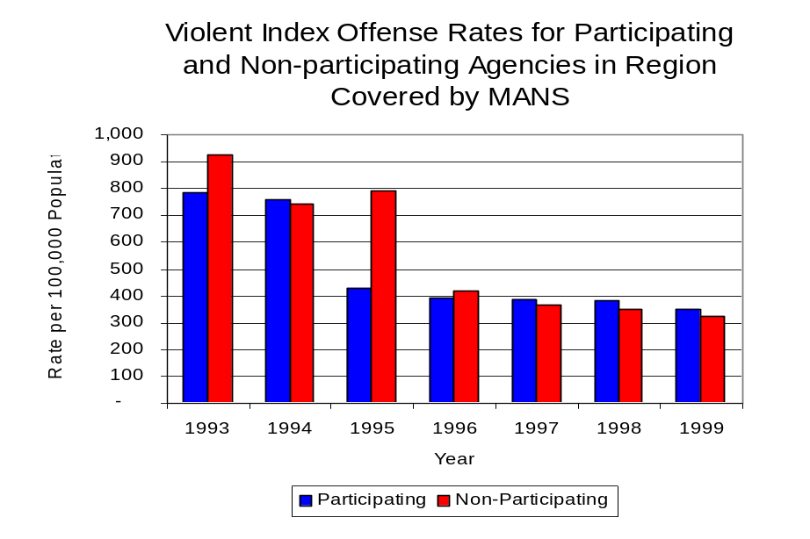
Figure 1
Source: ICJIA calculations using Illinois State Police and U.S. Census data
Across the 33 individual local law enforcement agencies covered by MANS’s jurisdiction, four agencies, the Joliet Police Department, the Will County Sheriff’s Office, Bolingbrook Police Department and the University Park Police Department, accounted for 81 percent of all violent offenses reported to the police (Figure 2). Twenty agencies had fewer than 25 violent offenses reported in 1999 and are excluded from Figure 2. When controlling for differences in the populations served by these law enforcement agencies, the violent Index offense rate ranged from 857 violent Index offenses per 100,000 population in Joliet to 290 offenses per 100,000 population in Peotone.
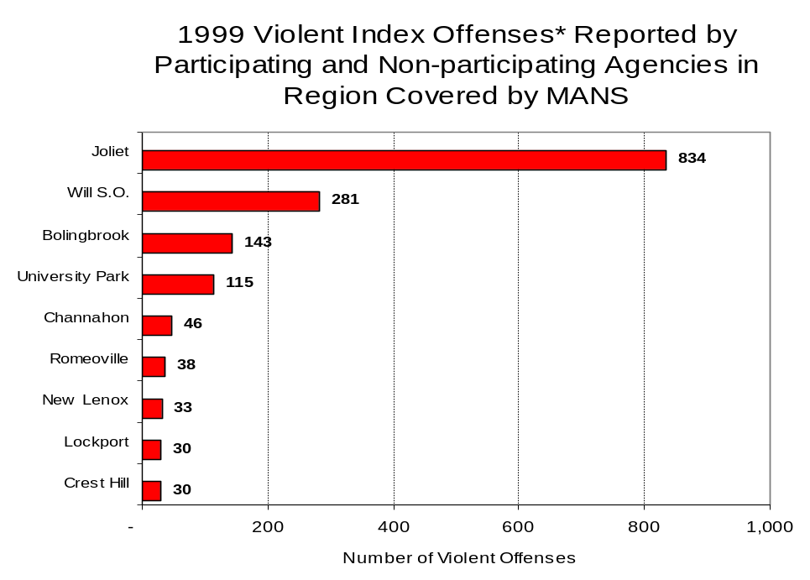
Figure 2
Source: Illinois State Police *Agencies reporting 25 or more violent offenses

An indicator of the workload that law enforcement agencies place on other components of the justice system is the number of arrests made by police, including those for violent and property Index offenses and drug offenses. Unlike offenses, which are what police must respond to, arrests represent those offenders who may eventually be processed through other components of the justice system, including the courts, county jails, and state and local correctional programs.

Between 1993 and 1999, the number of arrests for violent Index offenses made by law enforcement agencies in the region covered by MANS decreased 23 percent, from 1130 to 872. As with reported violent Index offenses, the majority (83 percent) of violent Index arrests were for aggravated assaults, followed by robberies (10 percent).

During the period analyzed, the violent Index arrest rate for the region covered by MANS decreased 37 percent, from 284 offenses per 100,000 population in 1993 to 179 arrests per 100,000 population in 1999. Similarly, the violent Index arrest rate in the participating agencies decreased 32 percent, from 265 to 179 offenses per 100,000 population, while the rate in the non-participating agencies decreased 52 percent, from 373 to 179 offenses per 100,000 population (Figure 3).

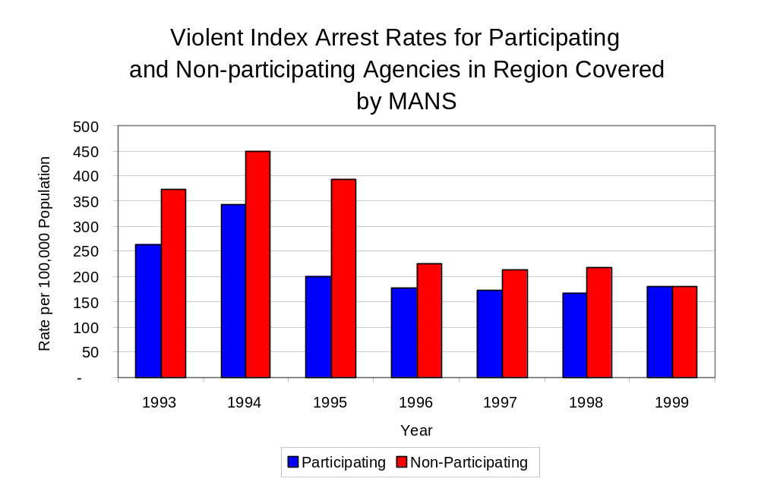
Figure 3
Source: ICJIA calculations using Illinois State Police and U.S. Census data

Similar to the number of violent Index offenses, the majority (83 percent) of arrests for violent Index offenses occurring in the two-county region covered by MANS were made by four agencies. Twenty-one agencies had fewer than 15 arrests for violent Index offenses reported in 1999 and are excluded from Figure 4. Of the 872 violent Index arrests made in 1999, the Joliet Police Department accounted for the majority (35 percent), followed by the Will County Sheriff’s Office (28 percent), then the University Park Police Department (10 percent) and the Bolingbrook Police Department (10 percent) (Figure 4).
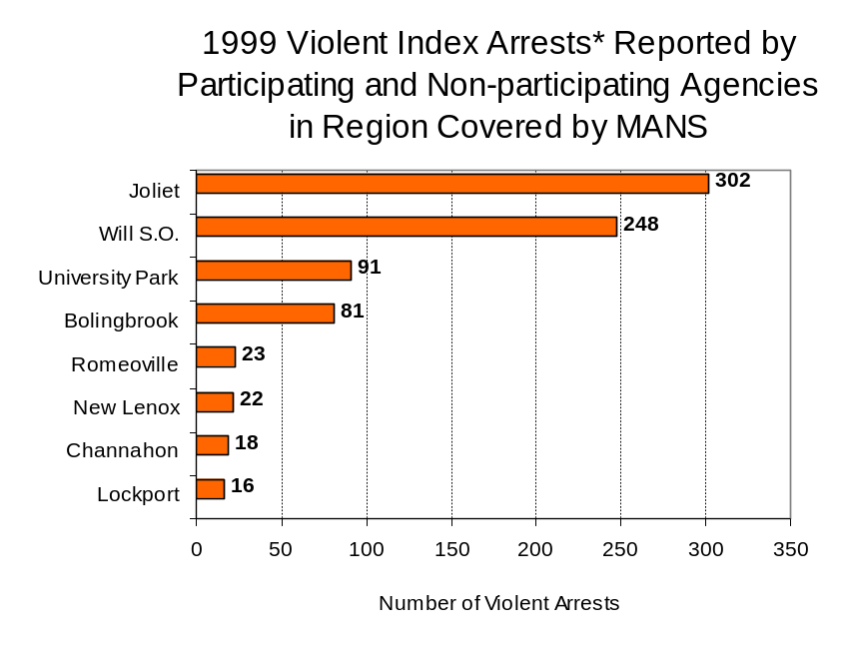
Figure 4
Source: Illinois State Police *Agencies reporting ten or more violent offenses
III. Trends in Drug Arrests

There are two sources of drug arrest data presented in this section. One source is the Illinois Uniform Crime Reporting (I-UCR) program that includes information submitted by local law enforcement agencies on the number of persons arrested for violations of Illinois’ Cannabis Control Act, Controlled Substances Act, Hypodermic Syringes and Needles Act, and Drug Paraphernalia Control Act. In addition, data on drug arrests made by Illinois’ MEGs and task forces are reported to the Illinois Criminal Justice Information Authority. In some jurisdictions, arrests made by the MEG or task force may be reported by both local law enforcement agencies through the I-UCR and to the Authority by the unit. In other jurisdictions, arrests made by the MEG or task force are only reported to the Authority by the unit. Therefore, in some instances drug arrests may be double counted – included in both local agency statistics reported to I-UCR and those of the MEG or task force. Currently there is no mechanism in place to ensure that drug arrest statistics are not being duplicated at both the local agency and MEG/task force level. This should be kept in mind when interpreting the information presented in the following section.

The majority of drug offenses in Illinois are violations of either the Cannabis Control Act – which prohibits the possession, sale and cultivation of marijuana – or the Controlled Substances Act – which prohibits the possession, sale, distribution or manufacture of all other illegal drugs, such as cocaine and opiates. Illinois also has various other laws prohibiting other drug-related activity. These include the Hypodermic Syringes and Needles Act – which prohibits the possession or sale of hypodermic instruments – and the Drug Paraphernalia Control Act – which prohibits the possession, sale or delivery of drug paraphernalia. In general, violations of Illinois Controlled Substances Act are considered to be more serious, since they primarily involve cocaine, heroin, methamphetamine, and hallucinogens, and are almost all classified under Illinois law as felonies. The majority of cannabis and drug paraphernalia offenses encountered by police, on the other hand, tend to be misdemeanor-level offenses.

In 1999, local law enforcement agencies in the counties covered by MANS reported 2,490 arrests for drug law violations, more than triple the number in 1993 (715 arrests). Every year between 1993 and 1999 arrests for violations of Illinois’ Cannabis Control Act out-numbered arrests for violations of the Controlled Substances Act in Grundy and Will counties combined. During the same period, the number of arrests for violations of the Cannabis Control Act in these two counties combined almost tripled, from 444 to 1,315. Arrests for violations of the Controlled Substances Act in the two counties combined increased 53 percent, from 259 to 549. In addition, arrests for violations of the Drug Paraphernalia Control Act, enacted in 1993, increased dramatically, from 6 in 1993 to 619 in 1999. Much of this increase can be attributed to a 1994 addition to the Drug Paraphernalia Control Act, which included the possession of drug paraphernalia as a violation. Because arrests for violations of the Drug Paraphernalia Control Act are frequently made in conjunction with other drug offense arrests, these arrests may be double-counted, thus skewing the actual number of drug arrests. Therefore, only arrests for violations of the Cannabis Control Act and Controlled Substances Act will be used for drug arrest comparisons between MANS and the participating and non-participating agencies.

During the period analyzed, the drug arrest rate for the Cannabis Control and Controlled Substances Acts combined, in the region covered by MANS more than doubled, from 177 arrests per 100,000 population in 1993 to 383 arrests per 100,000 population in 1999. Similarly, the drug arrest rate in the participating and non-participating agencies also more than doubled, from 177 to 365 arrests per 100,000 population and 172 to 465 arrests per 100,000 population, respectively. The arrest rate for MANS, on the other hand, decreased 26 percent, from 34 to 26 arrests per 100,000 population (Figure 5). Thus, the drug arrest rate tended to be higher collectively in the jurisdictions that did not participate in MANS than in those jurisdictions that participated in MANS.

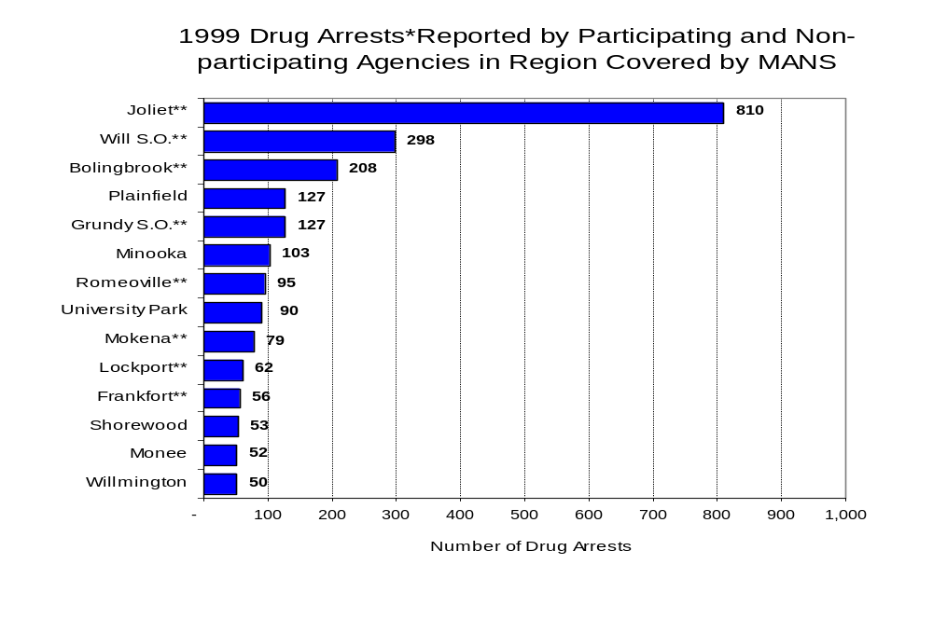
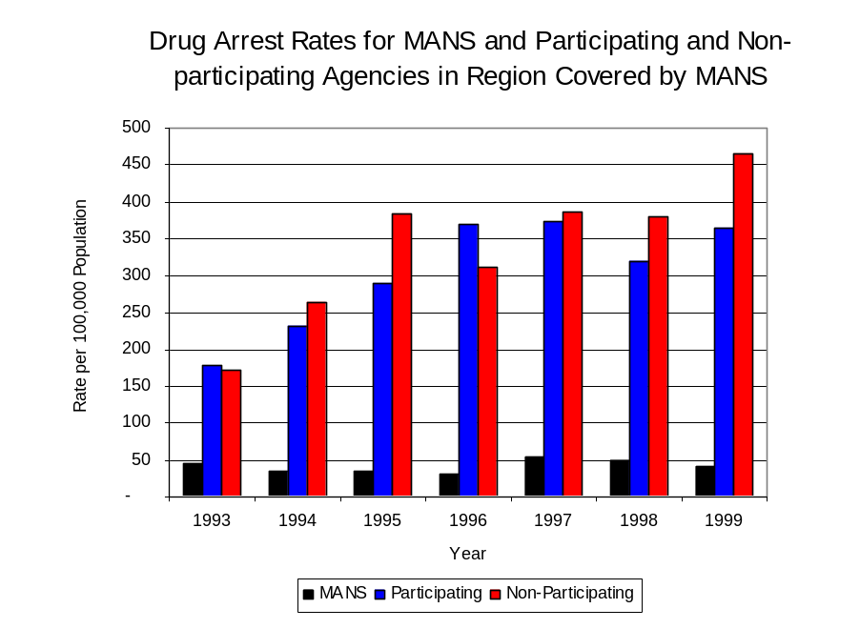
Across the individual local law enforcement agencies in the region covered by MANS, the number of total drug arrests ranged from two to 810. Of the 2,490 drug arrests made during 1999 in the two-county region, five agencies accounted for 63 percent of these drug arrests. Fourteen agencies had fewer than 50 drug arrests reported in 1999 and are excluded from Figure 6. Joliet accounted for more than one-third (33 percent), while the Will County Sheriff’s Office accounted for 12 percent, Bolingbrook Police Department accounted for 8 percent and Plainfield Police Department and Grundy County Sheriff’s Office each accounted for 5 percent of all drugs arrests in Grundy and Will counties (Figure 6). Among the 14 agencies with the highest number of drug arrests during 1999, eight participated in MANS.
Figure 6
Source: Illinois State Police *Agencies reporting 50 or more drug arrests
**Agencies participating in MANS
Figure 5
Source: ICJIA calculations using Illinois State Police and U.S. Census data

In addition to the dramatic difference in the number of drug arrests made, there are also
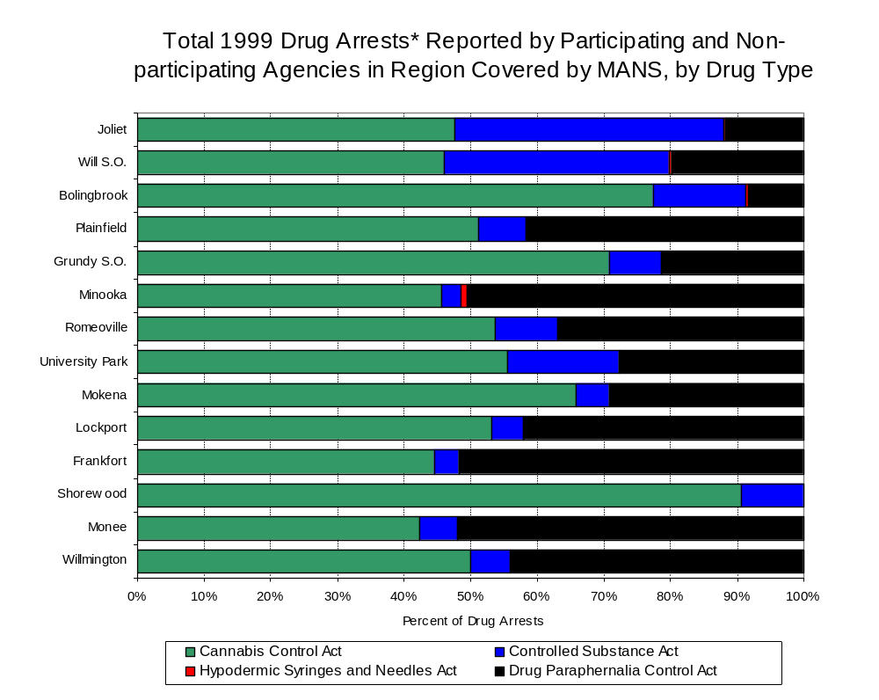
differences in the types of drug law violation arrests across the agencies in the region. In 1999, violations of the Cannabis Control Act accounted for the largest proportion of arrests across most individual agencies in the region covered by MANS (Figure 7).
Figure 7
Source: Illinois State Police *Agencies reporting 50 or more drug arrests

Between 1993 and 1999, the number of combined cannabis and controlled substances arrests made by MANS decreased about five percent, from 114 to 103 (Figure 8). Unlike drug arrests made by most local police departments in the region, violations of the Controlled Substances Act accounted for the majority of drug arrests made by MANS throughout most of the period analyzed. During the period analyzed, the number of MANS arrests for violations of the Cannabis Control Act increased 20 percent, from 58 to 72, while arrests for violations of the Controlled Substances Act barely decreased, from 92 to 91 (Figure 8).

Between 1993 and 1999, the proportion of drug arrests accounted for by violations of the Controlled Substances Act decreased for participating and non-participating agencies as well as MANS. In 1999, 56 percent of the drug arrests made by MANS were for violations of the Controlled Substances Act, compared to 84 percent in 1993. Similarly, in 1999, arrests for violations of the Controlled Substances Act accounted for 27 percent of the drug arrests made in the participating agencies and 9 percent for the non-participating agencies, compared to 40 percent and 20 percent, respectively, in 1993. Thus, arrests by MANS were more likely than the arrests by non-participating agencies to involve violations of Illinois’ Controlled Substances Act, as opposed to the Cannabis Control Act. One interpretation of this pattern is that MANS is more focused in who they are targeting and arresting than local departments, and are also getting a more serious drug law violator, since violations of the Controlled Substances Act are more likely to involve felony-level offenses.

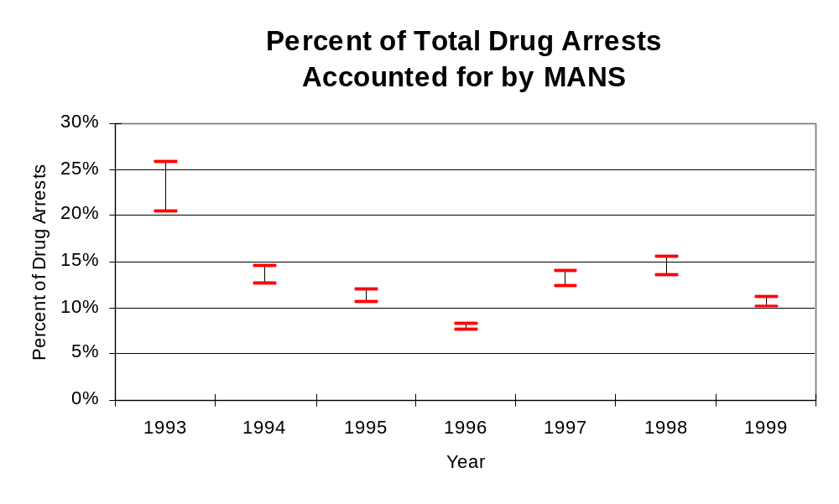
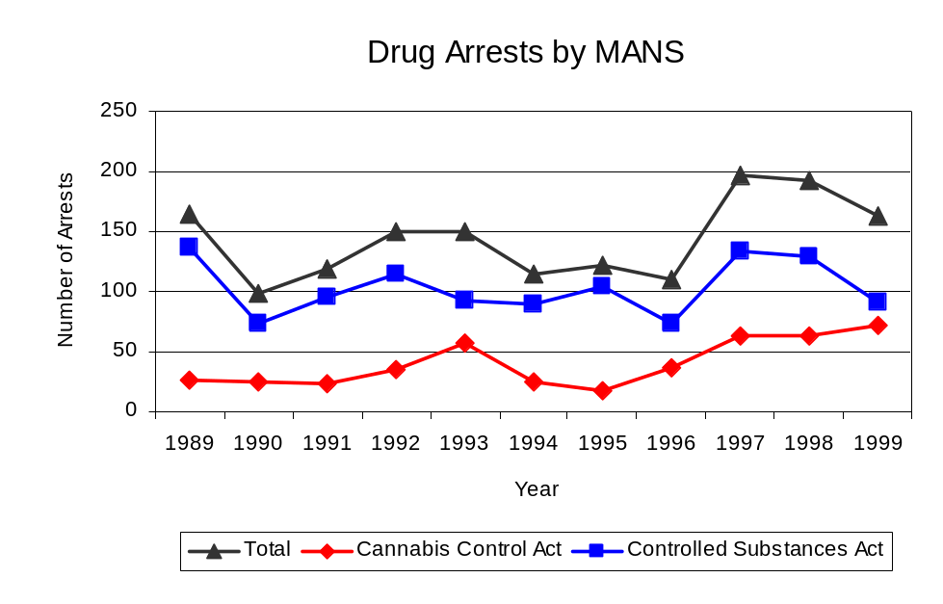
The data presented below represent the percent of total drug arrests made by agencies participating in MANS accounted for by MANS. An upper and lower bound is shown in Figure 9 which accounts for whether or not the units numbers are counted as part of the UCR submissions made by local departments (which is unknown at this point). The upper bound indicates the percentage of arrests if all of the MANS arrests are included in the local UCR submissions. The lower bound indicates the percentage if none of the MANS arrests are included in the local UCR submissions. It is estimated that the proportion of all drug arrests across participating agencies accounted for by MANS was between 20 to 26 percent in 1993, but decreased to between 10 to 11 percent in 1999. Thus, while officers assigned to MANS accounted for a small proportion of total officers in the region, they have also accounted for a decreasing proportion of the drug arrests in the region.
Figure 9
Source: ICJIA calculations using Illinois State Police and MANS data
Figure 8

Source: MANS

The number of arrests for violations of Illinois’ Cannabis Control Act in Grundy and Will counties totaled 1,315 in 1999, almost tripled the 444 arrests made for cannabis violations in 1993. Between 1993 and 1999, the proportion of all drug arrests accounted for by violations of the Cannabis Control Act in the two-county region remained relatively stable, increasing from 49 percent to 53 percent. Agencies not participating in MANS accounted for the largest portion (74 percent) of the total number of arrests for cannabis violations. MANS reported a total of 72 arrests for cannabis violations in 1999, 5 percent of the unit's drug arrests.

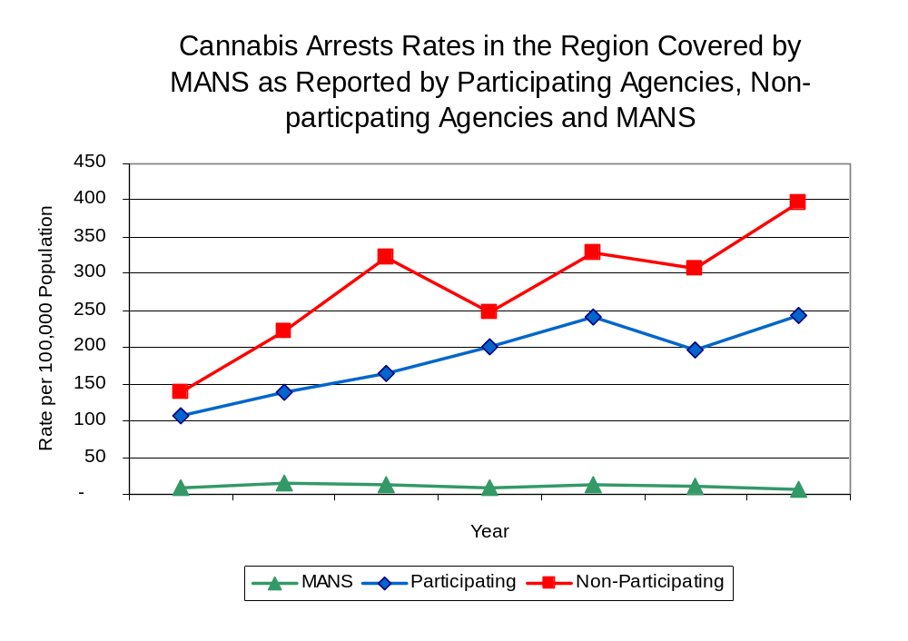
During the period analyzed, the cannabis arrest rate for the region covered by MANS more than doubled, from 112 arrests per 100,000 population in 1993 to 270 arrests per 100,000 population in 1999. The cannabis arrest rate in the participating agencies more than doubled, from 106 to 243 arrests per 100,000 population, while the arrest rate in the non-participating agencies almost tripled from 138 to 396 arrests per 100,000 population. The cannabis arrest rate for MANS stayed the same, from 18 to 18 arrests per 100,000 population (Figure 10). Thus, the arrest rate for violations of the Cannabis Control Act was collectively higher in the area served by non-participating agencies than in the combined jurisdictions of the participating agencies.
Figure 10
Source: ICJIA calculations using Illinois State Police and U.S. Census data

The data presented in Figure 11 represent the percent of cannabis arrests made by agencies participating in MANS accounted for by MANS. An upper and lower bound is shown which accounts for whether or not the unit’s numbers are counted as part of the UCR submissions made by local departments (which is unknown at this point). The upper bound indicates the percentage of arrests if all of the MANS arrests are included in the local UCR submissions. The lower bound indicates the percentage if none of the MANS arrests are included in the local UCR submissions. It is estimated that the proportion of cannabis arrests across participating agencies accounted for by MANS was between 14 to 17 percent in 1993, but decreased to 7 percent in 1999.

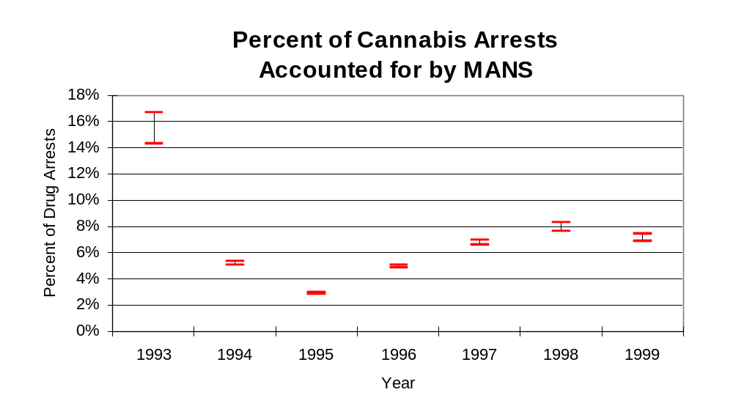
Source: ICJIA calculations using Illinois State Police and MANS data
Figure 11
In Grundy and Will counties the number of arrests for violations of Illinois’ Controlled Substances Act increased 53 percent between 1993 and 1999, from 259 to 549. Between 1993 and 1999, the proportion of all drug arrests accounted for by violations of the Controlled Substances Act in the two-county region decreased from 36 percent to 22 percent. In 1999, MANS reported 91 arrests for controlled substance violations, 56 percent of all drug arrests reported to the Authority by the unit.

Between 1993 and 1999, the arrest rate for controlled substances act violations for the region covered by MANS increased 42 percent, from 65 to 113 arrests per 100,000 population (Figure 12). The controlled substances arrest rate in the participating agencies increased 41 percent, from 72 to 122 arrests per 100,000 population, while the arrest rate in the non-participating agencies doubled, from 34 to 69 arrests per 100,000 population. The controlled substances arrest rate for MANS decreased 23 percent, from 28 to 23 arrests per 100,000 population (Figure 12). Thus, the Controlled Substances Act arrest rate was higher in the participating agencies than the non-participating agencies.
The data presented in Figure 13 represent the percent of controlled substances arrests made by agencies participating in MANS accounted for by MANS. An upper and lower bound is shown which accounts for whether or not the units numbers are counted as part of the UCR submissions made by local departments (which is unknown at this point). The upper bound indicates the percentage of arrests if all of the MANS arrests are included in the local UCR submissions. The lower bound indicates the percentage if none of the MANS arrests are included in the local UCR submissions. It is estimated that the proportion of controlled substances arrests across participating agencies accounted for by MANS was between 28 to 39 percent in 1993, but decreased slightly to between 16 to 19 percent in 1999.
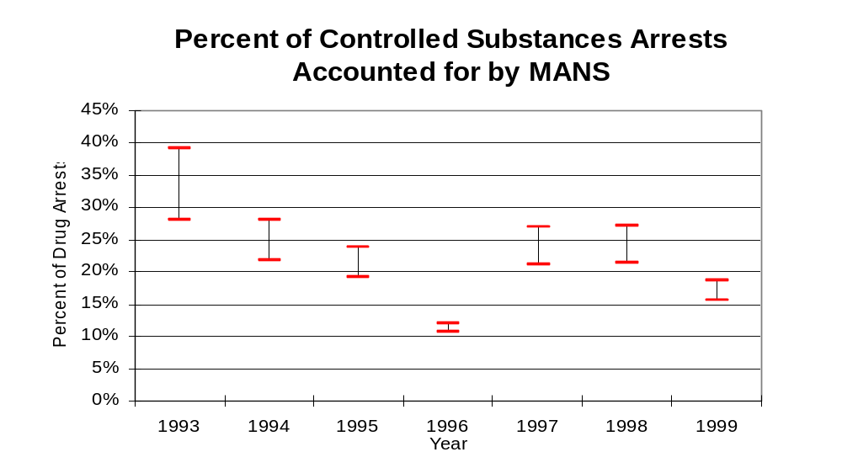
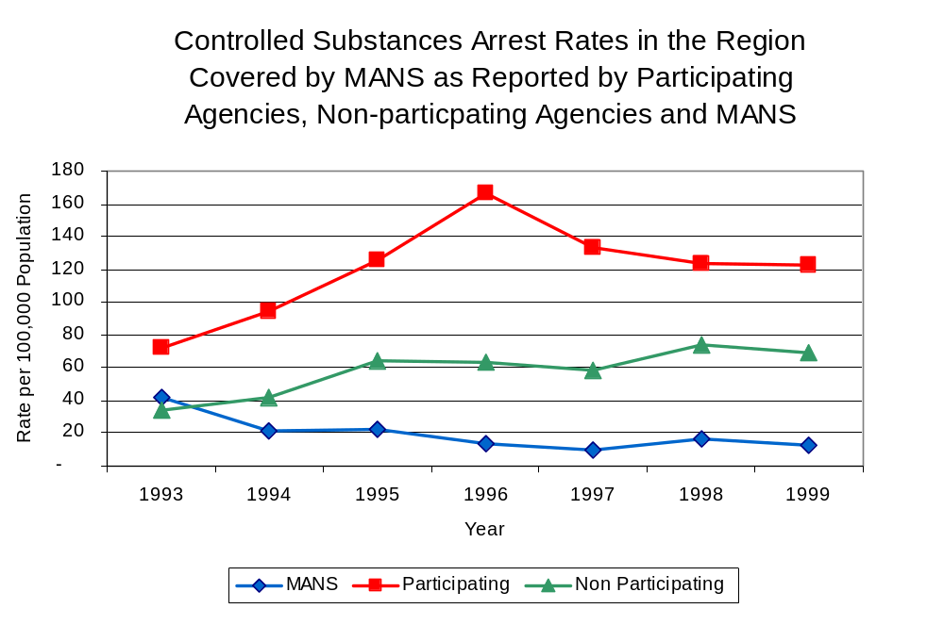
Figure 13
Source: ICJIA calculations using Illinois state Police and MANS data
Figure 12
Source: ICJIA calculations using Illinois State Police and MANS data
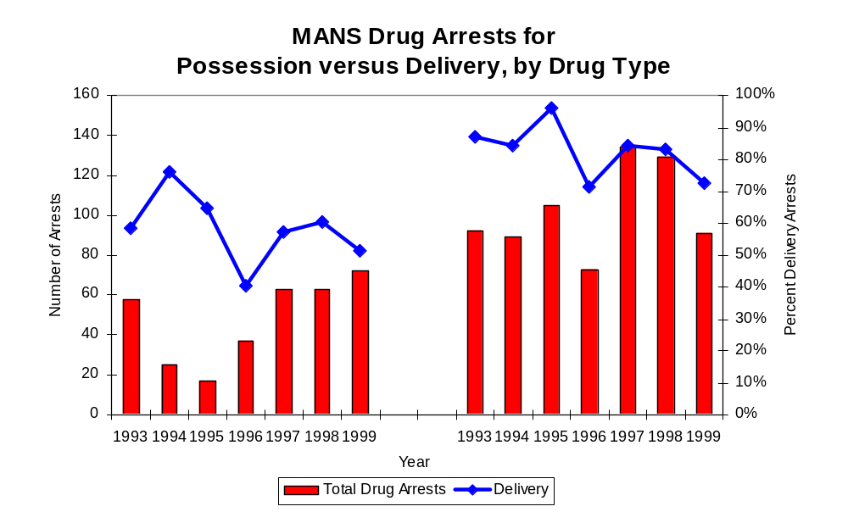
Although the majority of all drug arrests reported by MANS are for delivery, the proportion of delivery arrests for both cannabis and controlled substances arrests have declined, during the period analyzed. Between 1993 and 1999, the number of drug delivery arrests made by MANS decreased, from 114 to 103. Arrests for drug delivery accounted for over half (59 percent) of all drug arrests made by MANS between 1993 and 1999. When cannabis and controlled substance arrests were examined separately, during the period analyzed, arrests for delivery of controlled substances accounted for 83 percent of the total number of arrests made for violations of the Controlled Substance Act, whereas, arrests for the delivery of cannabis accounted for 53 percent of all arrests for violations of the Cannabis Act.
Figure 14
Cannabis
Controlled Substance
Source: ICJIA calculations using Illinois State Police and MANS data

IV. Trends in Drug Seizures

Drugs seized by law enforcement agencies are another indicator of the extent and nature of illegal drug trade in a jurisdiction. When illegal drugs are seized by law enforcement agencies, all or a portion of the total amount seized is submitted to a crime lab for analysis. Most agencies submit drugs to one of the Illinois State Police crime labs. These labs record the quantity of drugs submitted from each county. This section discusses trends in the quantities of illegal drugs seized and submitted to the Illinois State Police from local law enforcement agencies in Grundy and Will counties as well as the quantities of drugs seized by MANS. It is important to note, however, that while MANS data report the total quantities of drugs actually seized, local agency data only represent the quantities of seized drugs that are submitted to the Illinois State Police for analysis. County-level cannabis, cocaine and methamphetamine seizure rates for Illinois' 102 counties are provided in maps located in the Appendix of this report.

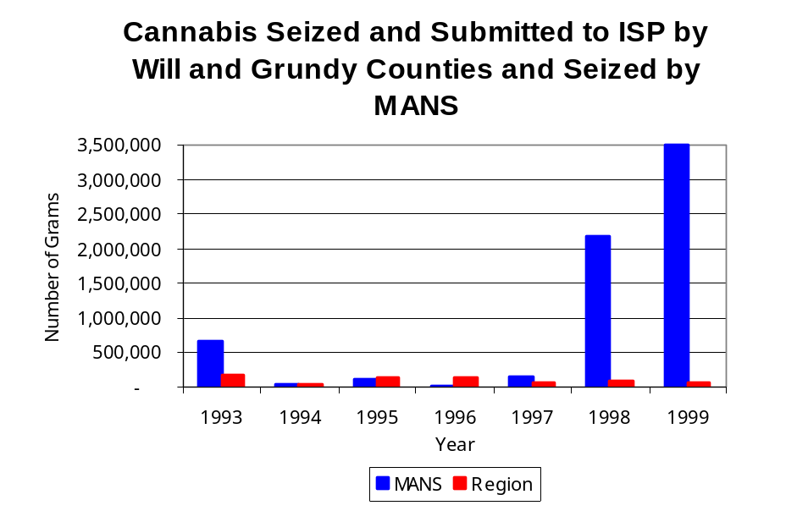
As in most Illinois jurisdictions, cannabis accounts for the majority of illegal drugs seized in the two-county region covered by MANS. The quantity of cannabis seized and submitted by law enforcement agencies in Grundy and Will counties decreased 68 percent, from 176,652 grams in 1993 to 56,978 grams in 1999. However, the quantity of cannabis seized by MANS increased between 1993 and 1999, from 657,435 grams to 3,496,079 grams (Figure 15). In 1999, MANS's cannabis seizure rate of 873,062 grams per 100,000 population was over 27 times higher than the statewide cannabis seizure rate of 31,533 grams per 100,000 population and over 74 times higher than the seizure rate of 11,704 grams per 100,000 population in the two-county region covered by MANS (Map 2).
Figure 15
Source: Illinois State Police and MANS

Between 1993 and 1999, a combination of crack and powder cocaine has accounted for a small proportion of drugs seized in the two-county region covered by MANS. However, the quantity of cocaine seized and submitted by law enforcement agencies Grundy and Will counties decreased, from 13,302 grams in 1993 to 6,121 grams in 1999. Between 1993 and 1999, the quantity of cocaine seized by MANS increased dramatically, from 5,287 grams to 480,199 grams. (Note: In order to adequately reflect the seizure data on the graph below, it was necessary to set the Y-axis scale to 50,000. Therefore, it should be noted that MANS reported nearly one-half million grams of cocaine were seized in 1999) (Map 3).

The proportion of all cocaine seized by MANS accounted for by powder cocaine remained relatively stable between 1993 and 1999, with the exception of 1998, whereas local seizures revealed a bit more variation. For MANS, powder cocaine accounted for the largest proportion of total cocaine seizures during most of the period analyzed, the proportion remained unchanged at 100 percent in both 1993 and 1999, while the proportion of powder cocaine seized in the two-county region covered by MANS decreased from 98 percent in 1993 to 76 percent in 1999. (Figure 16). In 1999, MANS' cocaine seizure rate of 119,918 grams per 100,000 population was dramatically higher than the cocaine seizure rate of 1,258 grams per 100,000 population in the two-county region covered by MANS, which was much less than the statewide cocaine seizure rate of 15,735 grams per 100,000 population.

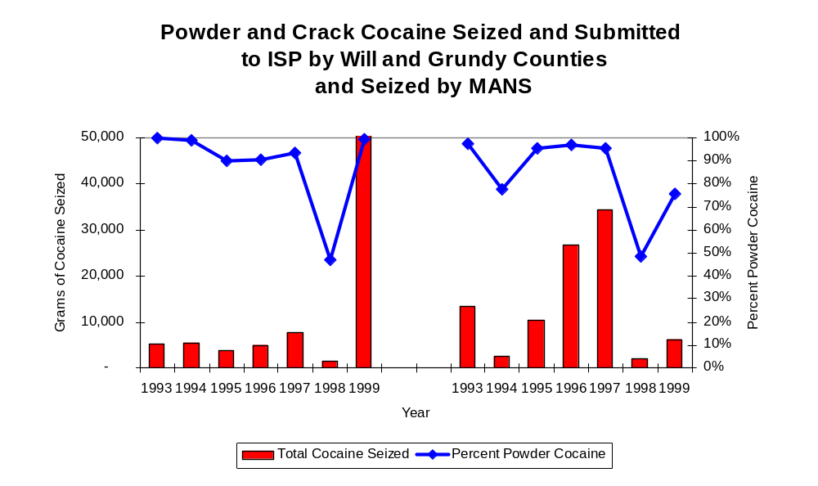
Figure 16
MANS
Region
Source: Illinois State Police and MANS
The total quantity of illegal drugs seized and submitted by law enforcement agencies in Grundy and Will counties decreased between 1993 and 1999, from 190,556 grams to 64,406 grams. On the other hand, the total quantity of illegal drugs seized by MANS has increased nearly five-fold, from 665,447 grams in 1993 to 3,979,740 grams in 1999.

During the period, methamphetamine seizures accounted for a relatively small proportion of total drugs seized and submitted by law enforcement agencies in Grundy and Will counties and seized by MANS. Between 1993 and 1998, there were no reported methamphetamine seizures by MANS. However, in 1999, 15 grams of methamphetamine were seized by MANS. On the other hand, there were 52 grams of methamphetamine seized by law enforcement agencies in Grundy and Will counties between 1996 and 1998, while no methamphetamine seizures were reported in the remaining years. In 1999, KAMEG had a methamphetamine seizure rate of less than four grams per 100,000 population, significantly lower than the statewide seizure rate of 98 grams per 100,000 population, respectively (Map 4).

Trends in Prosecutions for Drug Offenses and All Felonies

Although Illinois has one of the best court reporting systems in the country, the Administrative Office of the Illinois Court only collects information regarding the aggregate number of court filings. Currently, there are no statewide data available on court filings by offense type. The Administrative Office of the Illinois Courts reports data on felony criminal court cases. After screening a case and deciding it warrants further action, the state’s attorney must file formal charges in court. Felony cases can be punished by a probation term up to four years and incarceration for more than one year.

Between 1989 and 1999, the number of felony filings in the two-county region covered by MANS increased 66 percent, from 1,389 to 1,917 (Figure 17).
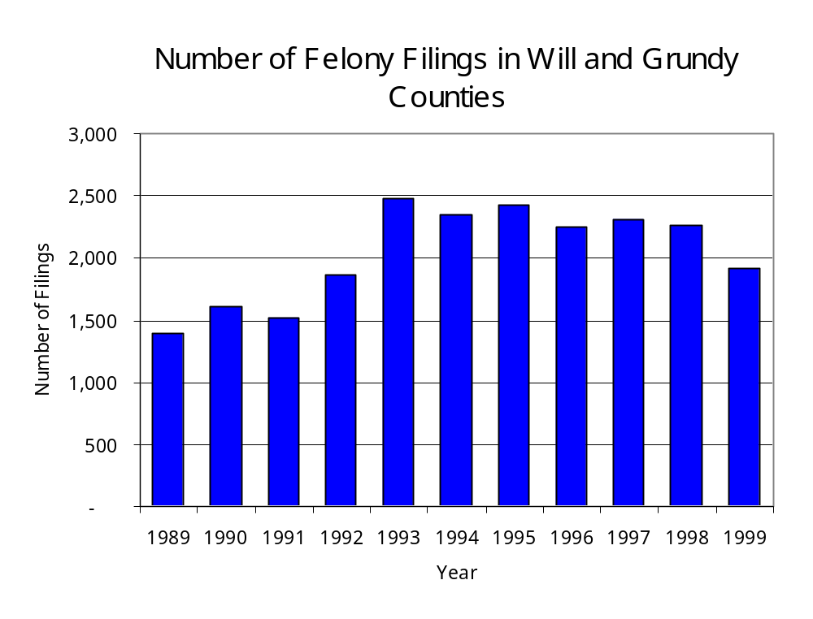
Figure 17
Source: Administrative Office of the Illinois Courts

Between 1989 and 1999, there were 1,349 drug prosecutions initiated as a result of MANS arrests in Grundy and Will counties. During this time, the number of MANS drug arrests decreased slightly, from 164 arrests in 1989 to 163 arrests in 1999 (Figure 18). Between 1989 and 1999, 85 percent of all drug arrests by MANS resulted in prosecution. Nearly three-quarters of MANS drug offender prosecutions during this period were for violations of the Controlled Substance Act. In some years, the proportion of arrests resulting in a prosecution exceeded 100 percent. This is due to some slight differences in the timing of an arrest and the filings of charges, or could be due to charges, rather than defendants, being reported by the unit. In addition, some offenders have charges filed, and a subsequent warrant issued, without an arrest taking place.

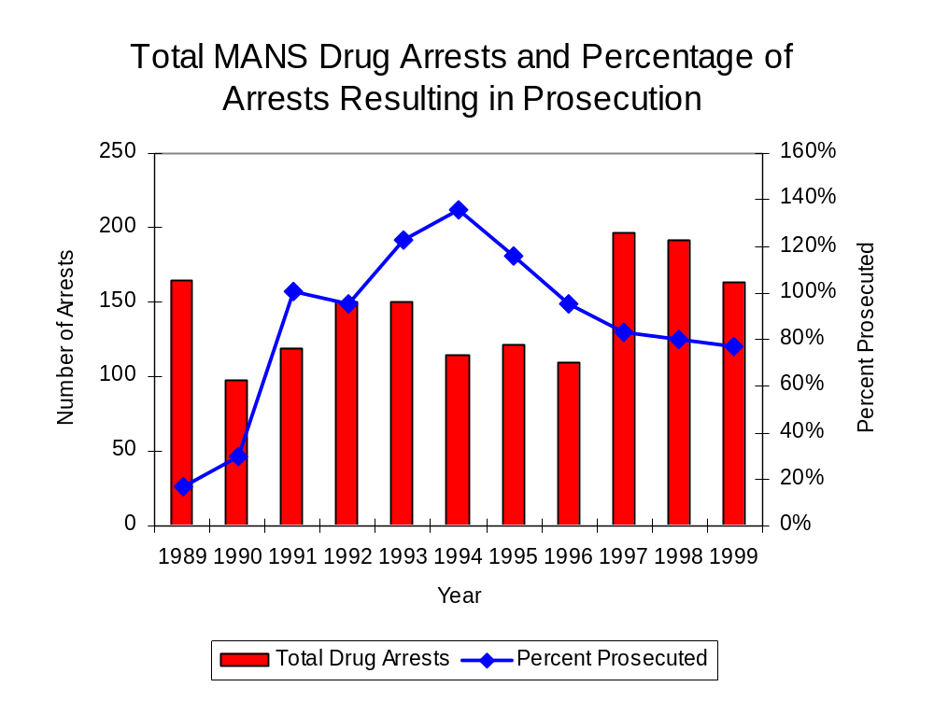
Figure 18
Source: MANS

Between 1989 and 1999, 86 percent (1,163) of the 1,349 drug offenders who were prosecuted as a result of MANS activity were convicted. Convictions for controlled substances accounted for 77 percent of all MANS initiated convictions during the period analyzed.

VI. Trends in Percent of Convicted Drug Offenders Sentenced to Prison

Anyone convicted of a felony in Illinois can be sentenced either to prison or probation, or receive conditional discharge. A number of factors influence the type and length of sentence imposed on convicted felons, including the severity of the crime, the offender’s criminal and social history, safety of the community and legislation affecting certain types of offenses. For some types of convictions, a sentence to prison is required by state statute.

Between 1989 and 1999, the number of offenders convicted of a felony and sentenced in the two-county region covered by MANS increased 62 percent, from 842 to 1354. Although the number of convicted felons sentenced to the Illinois Department of Corrections (IDOC) increased between 1989 and 1999, from 345 to 541, the proportion of felons sentenced to IDOC decreased slightly during the same period, from 41 percent to 40 percent of total felony sentences. In 1999, 720 probation sentences were imposed on convicted felons, 45 percent less than in 1989 (Figure 19). As a result, the proportion of felons sentenced to probation decreased from 59 percent in 1989 to 53 percent in 1999. Sentences other than prison or probation account for the remaining 7 percent of felony sentences imposed in 1999.
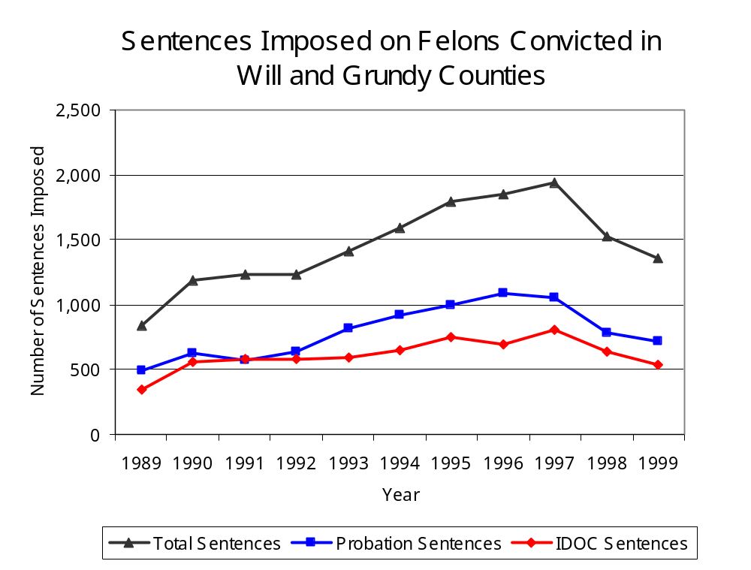
Figure 19
Source: Administrative Office of the Illinois Courts

Between 1989 and 1999, the number of MANS drug offenders convicted and sentenced increased from 28 to 126. During the period analyzed, the number of convicted MANS drug offenders sentenced to probation or jail each increased from 31 in 1989 to 64 in 1999, while the number of convicted MANS drug offenders sentenced to prison increased from 15 to 44 (Figure 20). In 1999, among those MANS drug offenders convicted and sentenced, probation sentences accounted for the largest proportion (48 percent), followed by prison sentences (41 percent) and jail sentences (11 percent).

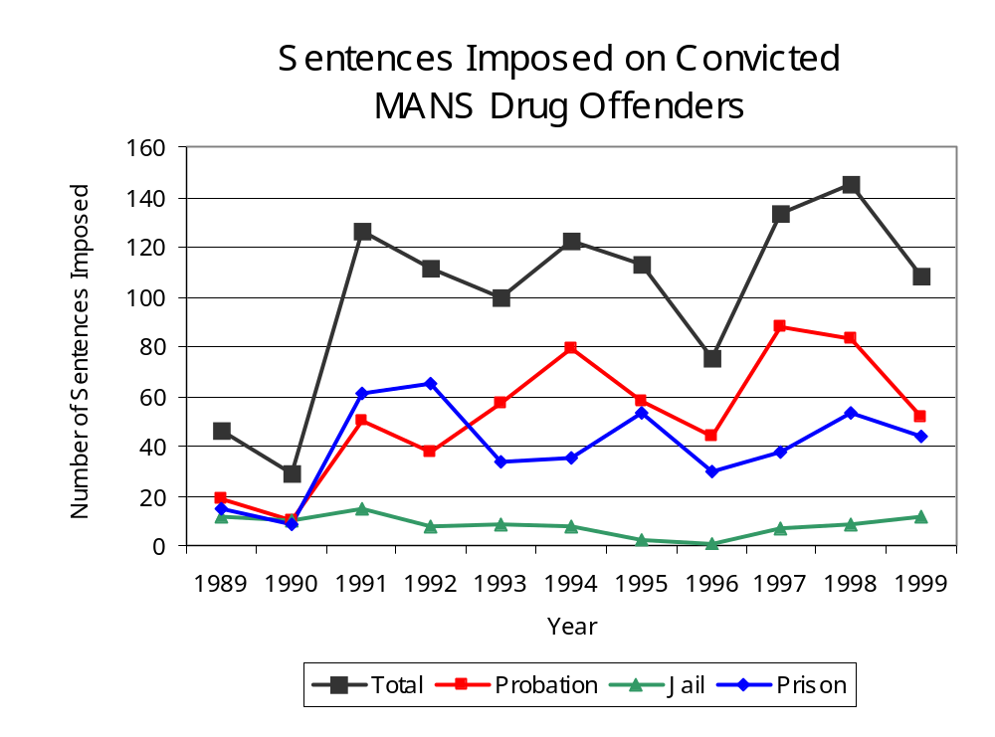
Figure 20
Source: MANS

Between state fiscal years 1989 and 1999, the number of new court commitments to IDOC’s Adult Division for drug offenses from the two-county region covered by MANS more than quadrupled, from 33 to 177. The number of drug offender admissions by MANS also increased from 13 to 61 between 1989 and 1999 (Figure 21). Thus, during the period analyzed, prison sentences resulting from MANS cases accounted for 35 percent of all drug-law violators sentenced to prison from the region where MANS operates.

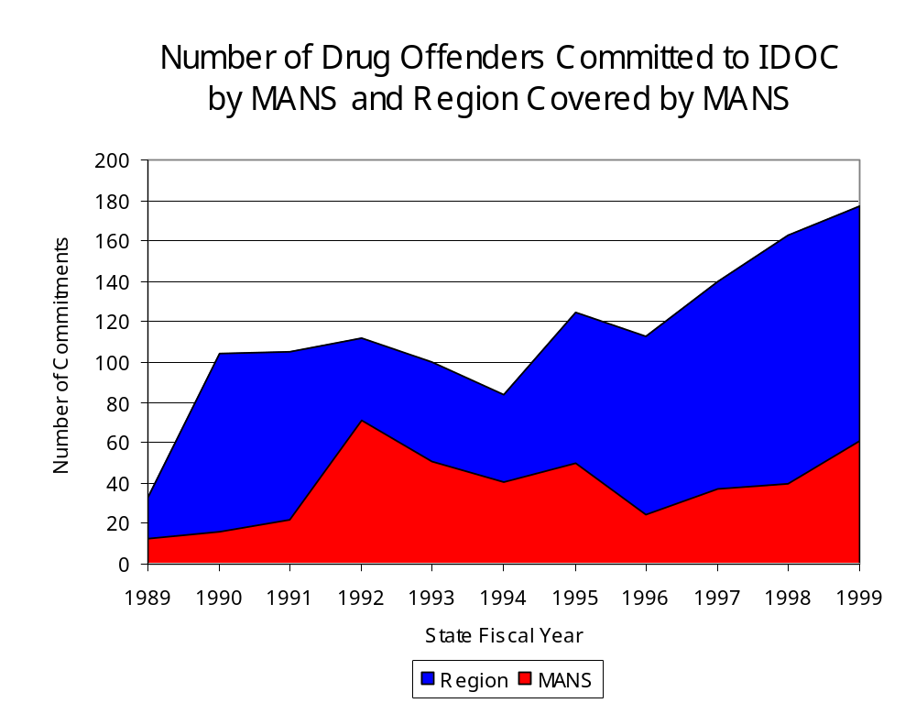
Figure 21
Source: Illinois Department of Corrections and MANS

During the period analyzed, drug offenders accounted for an increasing proportion of adults convicted and sentenced to prison from Grundy and Will counties. In 1989, drug offenses accounted for 15 percent of all commitments to IDOC, compared to 31 percent in 1999 (Figure 22).

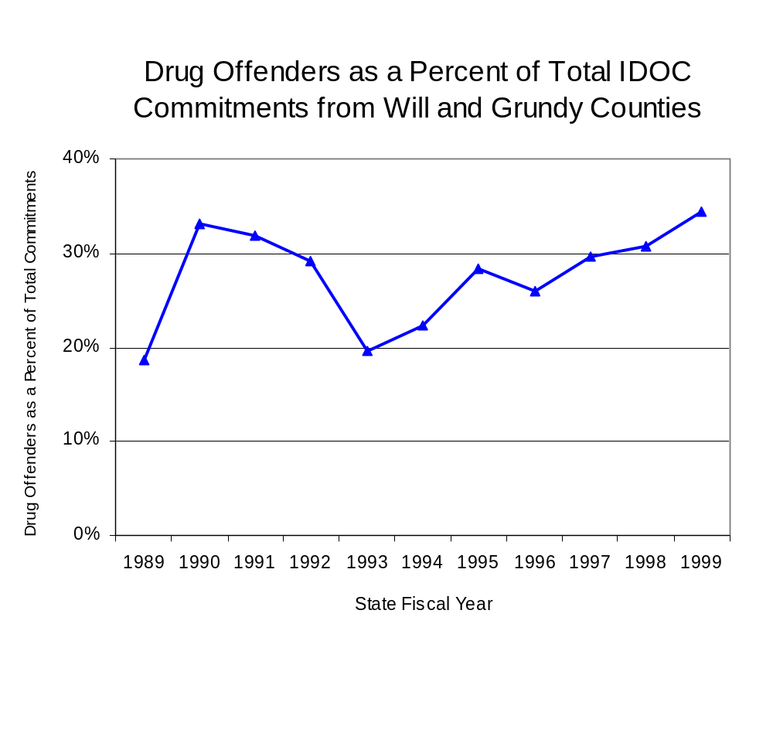
Figure 22
Source: Illinois Department of Corrections

Penalties for drug offenses were also examined between 1993 and 1999. Class 4 felonies accounted for the largest proportion (35 percent) of sentences to IDOC for drug offenses, followed by Class 1 felonies (30 percent), Class 2 felonies (21 percent) and Class X felonies (9 percent) and Class 3 felonies (6 percent). Between 1993 and 1999, the number of Class 4 felony sentences increased over four-fold, from 17 to 70, while Class 1 felony sentences more than doubled, from 23 to 5, Class 2 felony sentences more than doubled, from 12 to 31, Class X felony sentences increased from 9 to 17 and Class 3 felonies increased from 4 to 11, during the period analyzed (Figure 23).

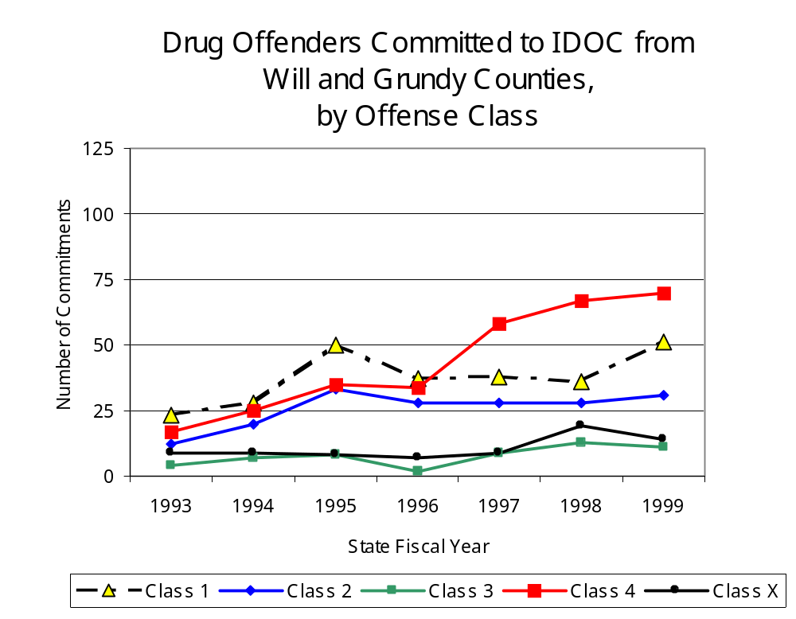
Figure 23
Source: Illinois Department of Corrections

Despite the dramatic increase in Class 4 felony sentences to IDOC between 1993 and 1999, the mean sentence length for Class 4 felonies remained relatively stable from 2.4 years in 1993 to 2.3 years in 1999. However, the mean sentence length for Class 1 felonies increased 30 percent during the same period, from 4.7 to 6.1 years, while the mean sentence for a Class 2 felony increased 5 percent, from 4.3 to 4.5 years. Class 3 sentence lengths remained unchanged at 3.0 years in both 1993 and 1999. Conversely, the mean sentence length for Class X felonies decreased slightly during the period analyzed, from 9.9 in 1993 to 9.7 years in 1999.

VII. Trends in Drug Treatment Admissions in MANS Region by Drug Type

In addition to considering indicators of the extent and nature of drug abuse as reported through the criminal justice system (for example, arrests and prison sentences), there are indicators of substance abuse available from other Illinois social service agencies. Overseeing and supporting treatment for substance users, whether they are referred from the criminal justice system or elsewhere, is the responsibility of the Illinois Department of Human Services’ Office of Alcoholism and Substance Abuse (OASA). It is important to note, however, that while OASA data represent the majority of the overall demand for substance abuse treatment in the state, some private programs provide treatment services to a smaller but significant number of clients who may not be included in the state’s reporting system.

In state fiscal year 1999, OASA reported 2,063 admissions for alcohol or drug abuse treatment from Grundy and Will counties, 40 percent more than the 827 admissions in 1989 (Figure 24). Among the 2,063 admissions to substance abuse treatment in state fiscal year 1999, 44 percent (1,057) reported alcohol as their primary substance of abuse, while abuse of illicit substances accounted for more than one-half (54 percent) and 1 percent reported no primary substance of abuse.
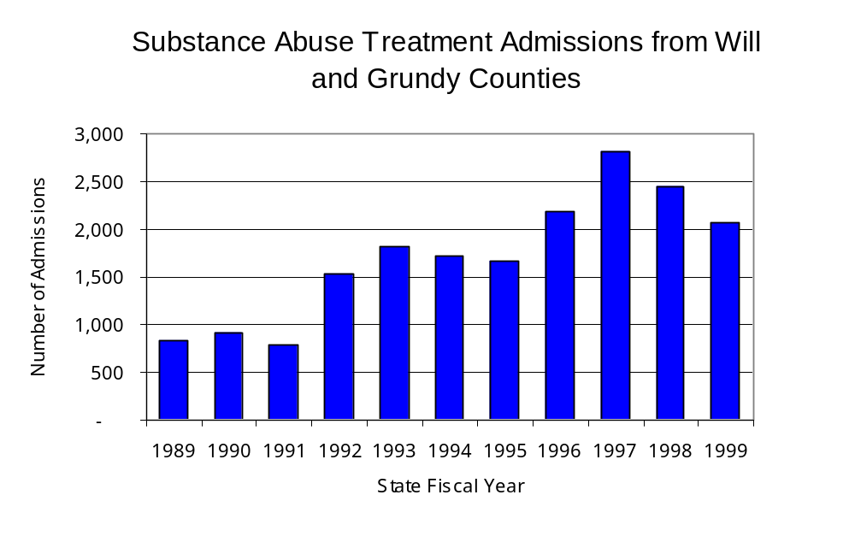
Figure 24
Source: Illinois Department of Human Services'
Office of Alcoholism and Substance Abuse

While drug treatment admissions can be considered a measure of the demand placed on a specific component of the human services system within Illinois, the extent and nature of drug treatment admissions could also be indicative of the substance abuse problem within a particular region. In some respects, the characteristics of those admitted to drug treatment can be considered a profile of the most serious drug abusers in the community, since admission to treatment requires a documented, formal assessment of a drug problem and a level of substance abuse warranting treatment. By comparing the types of drugs of abuse reported by those admitted to substance abuse treatment with the types of drugs involved in law enforcement agency arrests, one can get a sense of the degree to which arrests reflect the drugs which are most problematic within a community.

In the following analyses, the percent of arrests accounted for by drugs classified under Illinois’ Controlled Substances Act (primarily cocaine, heroin, and methamphetamine) versus the Cannabis Control Act (marijuana) across the participating agencies combined, non-participating agencies combined and MANS are compared to the proportion of drug treatment admissions accounted for by these groups of substances. From these comparisons, a number of general conclusions can be made. First, the proportion of arrests made by MANS accounted for by drugs other than marijuana (Controlled Substances Act offenses) was very close to the proportion of drug treatment admissions from the covered region accounted for by these substances. Thus, there is considerable convergence between the drugs involved in MANS arrests and treatment admissions. On the other hand, the majority of arrests by local police departments (including those participating in MANS and non-participating agencies) were for cannabis offenses. Thus, while local arrests may reflect the most widely available and used drug in the region, they tend not to involve the substances considered to be most serious (i.e., felony versus misdemeanor) nor the substances individuals are seeking and receiving treatment for (Figure 25).

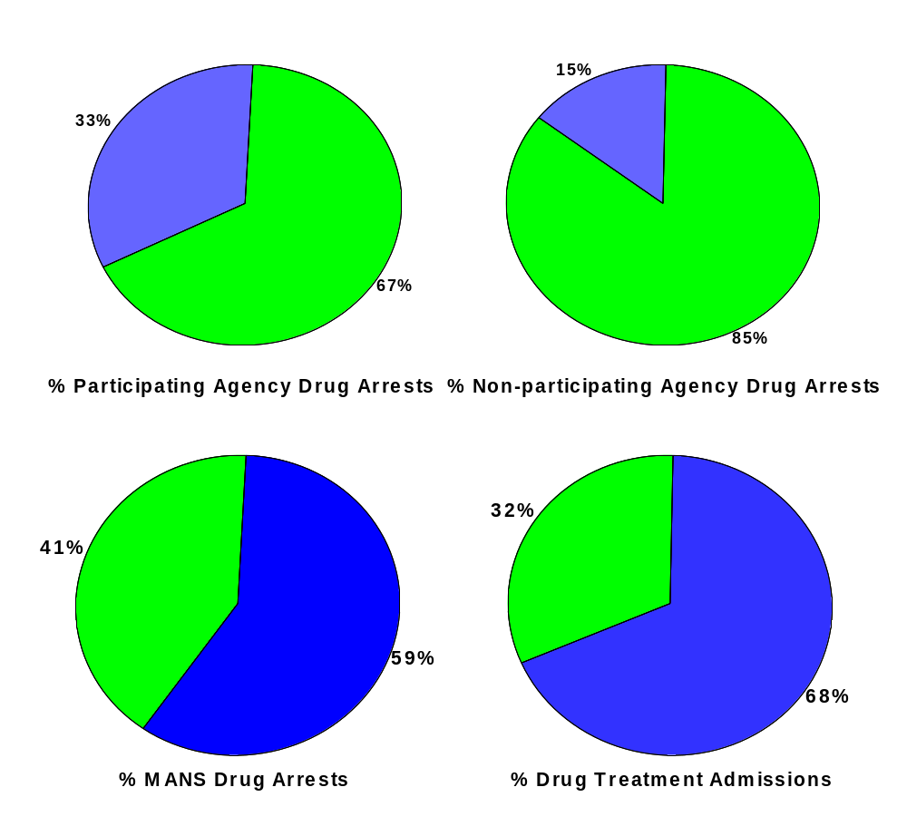
CannabisControlled Substances
Comparison of Drug Arrests by MANS and Participating and Non-participating Agencies vs. Drug Abuse Treatment Admissions in Grundy and Will Counties, 1999
Source: Illinois Department of Human Service's Office of Alcoholism and Substance Abuse and WCITF
Figure 25

VIII. Trends in Drug Exposed Births

Illinois continues to experience the effects of prenatal substance abuse. In Illinois, if a baby is born and thought to have been exposed to illegal substances or alcohol, either through observation by physicians or toxicology tests, the case is reported to the Illinois Department of Children and Family Services. These cases are then investigated by DCFS to verify the child’s prenatal exposure to either alcohol or illegal substances. Between state fiscal years 1989 and 1999, nearly one-half (50) of Illinois’ 102 counties reported at least one case of a substance-affected infant.

Between state fiscal years 1989 and 1999, the number of drug-exposed infant cases reported in the two-county region covered by MANS increased from 24 to 33. Between state fiscal years 1989 and 1999, 332 cases, or 53 percent of all cases reported, were verified as involving prenatal drug use by a DCFS investigation. Mirroring the trend of reported cases, verified cases of drug-exposed infants in the MANS region also increased between 1989 and 1999 from 19 to 29 (Figure 26).
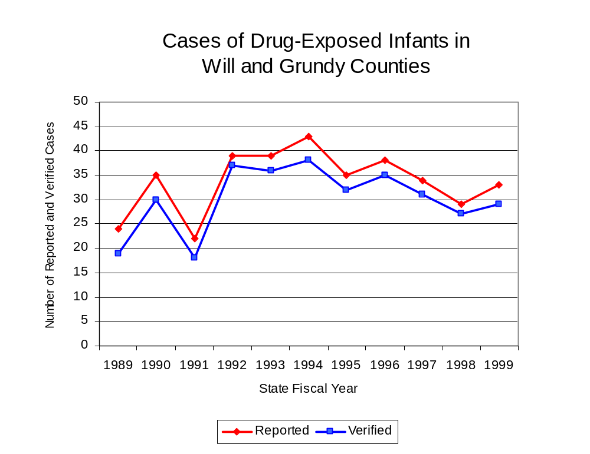
Figure 26
Source; Illinois Department of Children and Family Services

IX. Summary of Drug Situation

Although the distribution of illegal drugs is difficult to measure precisely, data obtained from criminal justice sources can be helpful in estimating drug availability. Information from a recent survey of Illinois drug enforcement units, as well as the most up-to-date data available on drug price, are presented as indicators of the drug supply in Illinois.

In 1995, 1996 and 1998, the Authority conducted a survey of each MEG and task force in Illinois to gauge the perceived availability of drugs in the areas they cover. Questions were asked concerning the availability of specific drugs, and results were analyzed by region of the state. MEGs and task forces are classified as being either urban, rural or mixed urban/rural based upon the classification of the county(s) that each unit covers, and, for purposes of this report, are compared to the average of similar units.

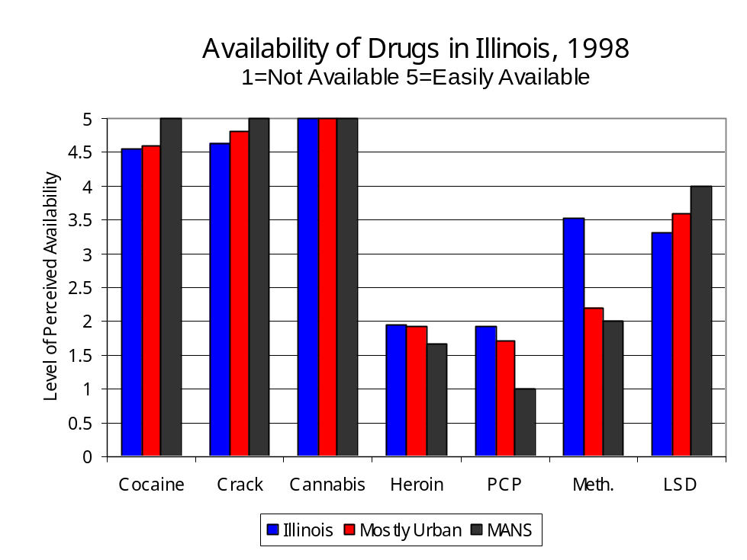
According to MANS survey responses, cannabis, cocaine and crack continued to be the most visible drugs on the street and were all reported to be “readily available” across all regions analyzed. While perceived availability of most drugs remained relatively unchanged in the two-county region covered by MANS, the perceived availability of Methamphetamine has decreased slightly since the 1996 survey, while all other drug types increased slightly across Illinois and all MEGs and task forces in mixed urban/rural regions similar to MANS. Methamphetamine was reported as moderately available across Illinois but available to a somewhat lesser degree in the region covered by MANS and by all MEGs and task forces in mixed urban/rural regions. On the other hand, LSD appears to be more readily available in the two-county region covered by MANS than across the state and all other MEGs and task forces in mixed urban/rural regions (Figure 27).
Figure 27
Source: Authority survey of Illinois MEGs and task forces

Another market indicator that can be used to assess availability is drug price. Lower prices tend to suggest a sufficient supply to meet demand, while increasing prices indicate decreased availability.

Based on a statewide survey of MEG and task force units, the average price of cocaine, crack and heroin appear to be relatively stable across all regions surveyed in 1998, while prices for PCP and cannabis appear to vary somewhat across Illinois. The average price of cannabis and heroin in the region covered by MANS decreased between 1996 and 1998, while it increased in the other mixed urban/rural regions. The 1998 average price of cocaine reported across Illinois was $98 per gram, compared to $90 per gram reported by MANS and $89 per gram reported by all MEGs and task forces in other mixed urban/rural regions (Figure 28). On the other hand, the average price of heroin in the region covered by MANS was reported as $200 per gram, higher than the price of $165 per gram across Illinois and the price of $138 per gram reported by all other MEGs and task forces in mixed urban/rural regions. In 1998, the average price of cannabis was reported as approximately $7 per gram in the MANS region, $11 per gram in primarily mixed urban/rural regions and $8 per gram across Illinois.

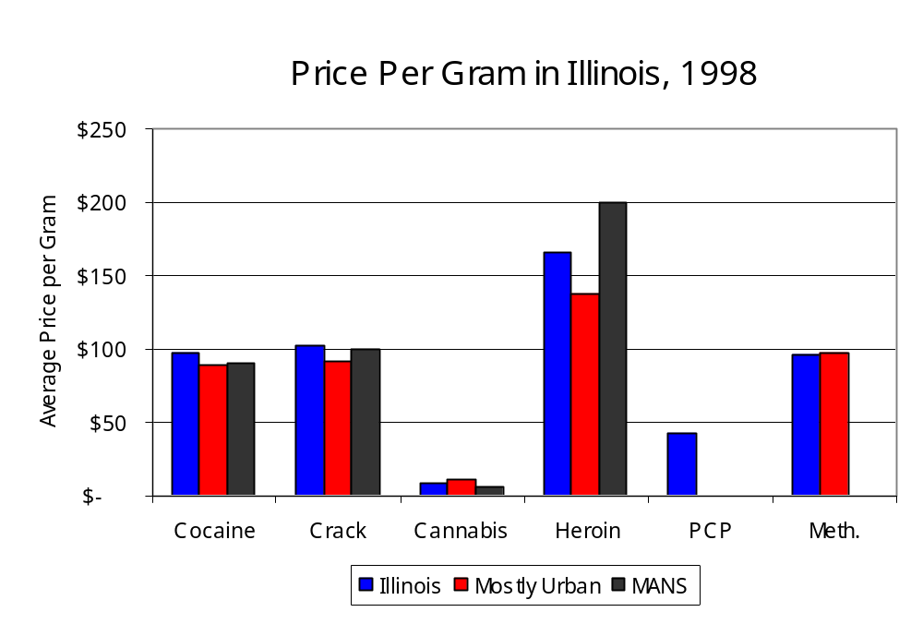
Figure 28
Source: Authority survey of Illinois MEGs and task forces

X. Appendices
1999 Percent of Illinois'
County-level Population Covered by an Authority-funded Multi-jurisdictional Enforcement Group or Task Force
Map 1
* Shaded counties indicate that at least one law enforcement agency within the county participates in a MEG or task force
Percent of County Population Covered by MEG or Task Force

1999 Illinois
Cannabis
Seizure Rates, by County
Map 2
Cannabis Seizure Rate
(rate per 100,000 population)
1999 Illinois
Cocaine
Seizure Rates, by County
Map 3
Cocaine Seizure Rate
(rate per 100,000 population)
1999 Illinois Methamphetamine
Seizure Rates, by County
Map 4
Methamphetamine Seizure Rate
(rate per 100,000 population)

Bibliography

Administrative Office of the Illinois Courts, Annual Report to the Supreme Court of Illinois.
1989 through 1999 reports, Springfield, Illinois.

Administrative Office of the Illinois Courts’ Probation Division, Statewide Probation Data
Report. 1989 through 1999 reports, Springfield, Illinois.

Illinois Department of Human Services’ Office of Alcoholism and Substance Abuse. Data
provided for state fiscal years 1989 through 1999, Springfield, Illinois.

Illinois Department of Children and Family Services, Child Abuse/Neglect Statistics Report,
1989 through 1999 reports, Springfield, Illinois.

Illinois Department of Corrections. Data provided for state fiscal years 1989 through 1999,
Springfield, Illinois.

Illinois State Police, Crime in Illinois. 1993 through 1999 reports, Springfield, Illinois.

Illinois State Police, Drug Statistics Report. Monthly reports, January 1989 through
December 1999, Springfield, Illinois.

Joliet Metropolitan Area Narcotics Squad. Monthly reports, January 1989 through December
1999, Joliet, Illinois.

U.S. Bureau of the Census.


George H. Ryan, Governor
Peter B. Bensinger, Chairman
Candice M. Kane, Executive Director

